Mini-Review

The Potential of Microphysiological Systems for Artificial Intelligence assisted Rapid Drug Discovery
Arun Asif ¹ and Abdul Rahim Chethikkattuveli Salih ^{2,}
¹Department of Mechatronics Engineering, Jeju National University, Jeju-si, Jeju-do, Republic of Korea, 63243.
²BioSpero Inc., Jeju Science Park, Jeju-si, Jeju-do, Republic of Korea, 63243
*Correspondence: arunasif@hotmail.com;
Abstract
The continuous evolution of deep learning tools with expanded applications in biology presents a great opportunity to improve drug analysis. The recent emergence of microphysiological tools has revolutionized the field of drug analysis owing to its human mimicking capacity. The convergence of artificial intelligence with automated microphysiological systems (MPS) may open the scope for speed-boosting drug discovery and development. Organizing on a chip technology application at a large scale will reduce the cost and time for the discovery of lead compounds for yet uncured diseases. Furthermore, the rapidly accumulated data from MPS-based analysis for new drug compounds with their initial indication will help eliminate the potentially irrelevant drugs at the earliest stage possible.

Keywords: microphysiological systems; artificial intelligence; drug discovery; mini-review; deep learning;
Introduction
The evolution of microphysiological systems (MPS) and organ-on-a-chip (OoC) technology in the previous decade has brought up a powerful alternative to animal models for drug testing. Meanwhile, developing microfluidic sensors and their integration in organ chips and microplates to monitor the cellular microenvironment in real-time has enhanced the analytical capacity of these MPS platforms[1-3]. In addition, the rapid accumulation of sensor-based data offers the opportunity for data mining tools to implement deep learning-based predictions for augmented drug development. Concerted efforts of academia and industry to bypass the laborious conventional drug discovery techniques have built machine learning tools for a rapid drug discovery process [4,5]. Lately, it took 21 days for Insilico Medicine – an artificial intelligence-based company – to identify drug candidates for the treatment of fibrosis[6]. Similarly, another AI-based company Atomwise collaborated with IBM to predict lead candidates for West African Ebola virus infection[7]. Figure 1 presents machine learning-assisted drug design and drug analysis.

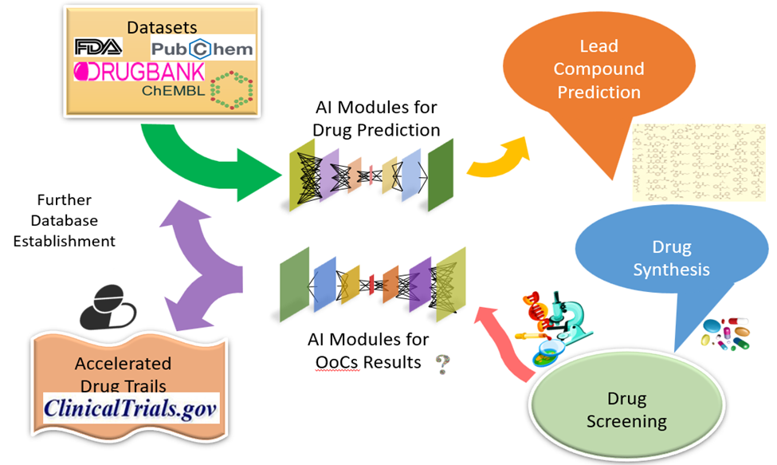
Fig. 1. Machine learning assisted drug design and drug analysis.
Conversely, a conventional method to identify a potential lead compound for treatment takes at least two years, with only a 10% success rate in clinical trials. Figure 2 presents real-time sensors assisting in accelerated drug screening.
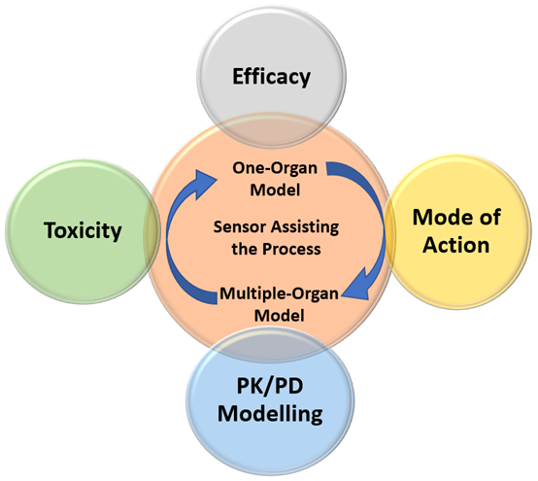
Fig. 2. Real-time sensors assisting in accelerated drug screening.
OoC technology-based MPS have the capacity to rapidly evaluate the predicted lead compounds for pre-clinical trials. Mounting evidence suggested that OOC-based drug toxicity analysis for multiple drugs represented a better assessment in comparison with the animal models. OOC-based MPS rebuild the cellular microenvironment mimicking the human pathophysiology in the most relevant possible way to assess the drug candidates. OOC provide the system to analyze the drug efficacy and toxicity with respect to a single organ or by combining multiple organs to evaluate the crosstalk of cellular responses under the influence of a specific drug candidate. Initially, it was challenging to monitor the microenvironmental changes in the OOC systems, which are now assisted by real-time sensors to monitor multiple factors of tissue development and tissue-tissue interactions. Implementing multiple sensors in combination with MPS may facilitate faster disease and drug analysis at a relatively larger scale.
Conclusion
The predictability of OOC platforms closer to human physiology makes them an ideal candidate for drug screening and helps in emitting unreliable drug candidates at the earliest possible level. The evolving integration of sensors in MPS has the potential to accelerate drug development by increasing the success rate of drug candidates and cutting short the economic burden.
References
- Asif, A.; Kim, K. H.; Jabbar, F.; Kim, S.; Choi, K. H., Real-time sensors for live monitoring of disease and drug analysis in microfluidic model of proximal tubule. Microfluidics and Nanofluidics 2020, 24 (6), 1-10.
- Asif, A.; Park, S. H.; Soomro, A. M.; Khalid, M. A. U.; Salih, A. R. C.; Kang, B.; Ahmed, F.; Kim, K. H.; Choi, K. H., Microphysiological system with continuous analysis of albumin for hepatotoxicity modeling and drug screening. Journal of Industrial and Engineering Chemistry 2021, 98, 318-326.
- Chethikkattuveli Salih, A. R.; Hyun, K.; Asif, A.; Soomro, A. M.; Farooqi, H. M. U.; Kim, Y. S.; Kim, K. H.; Lee, J. W.; Huh, D.; Choi, K. H., Extracellular Matrix Optimization for Enhanced Physiological Relevance in Hepatic Tissue-Chips. Polymers 2021, 13 (17), 3016.
- Lo, Y.-C.; Rensi, S. E.; Torng, W.; Altman, R. B., Machine learning in chemoinformatics and drug discovery. Drug discovery today 2018, 23 (8), 1538-1546.
- Ahmed, F.; Lee, J. W.; Samantasinghar, A.; Kim, Y. S.; Kim, K. H.; Kang, I. S.; Hudson, M. L.; Lim, J. H.; Choi, K. H., SperoPredictor: An integrated machine learning and molecular docking-based drug repurposing framework with use case of Covid-19. Frontiers in Public Health, 1484.
- Mak, K.-K.; Balijepalli, M. K.; Pichika, M. R., Success stories of AI in drug discovery-where do things stand? Expert opinion on drug discovery 2022, 17 (1), 79-92.
- Kumar, A.; Gadag, S.; Nayak, U. Y., The Beginning of a New Era: Artificial Intelligence in Healthcare. Advanced Pharmaceutical Bulletin 2021, 11 (3), 414.

