Semantic Situation Reporting Mechanism Based on 4W'H Ontology Modeling in Battlefield
Naeem Iqbal¹, Murad Ali Khan¹, Atif Rizwan¹ and Do-Hyeun Kim^{1,*}
¹ Department of Computer Engineering, Jeju National University, Jeju-si 63243, Korea
* Correspondence: kimdh@jejunu.ac.kr; Tel.: +82-64-7543658
Abstract
Semantic ontologies have recently been considered essential in knowledge representation systems to form interactive user-centric query systems. A well-defined semantic ontology enables the machine to process, analyse, and manage information effectively. Therefore, it is gaining significant importance in the battlefield situations domain to offer several services to military officials; for example, it enables military officials to deduce battlefield situations information to drive effective decisions in a short time during tactics. This paper presents a battlefield ontology based on a 4W'H architecture using battlefield terms to enhance the existing Army Tactical Command Information System (ATCIS) to intelligent ATCIS. Furthermore, we used a well-known ontology editor, Protégé, to design an ontology to report battlefield situations semantically and effectively. In addition, a use case is defined in order to reveal the effectiveness of the designed semantic ontology based on 4W'H architecture.

Keywords: ontology, battlefield situations, semantic data processing, battlefield tactics, battlefield terms;
Introduction
Today, semantic-based ontologies have been adapted as a fundamental model for knowledge representation and information retrieval systems. The main objective of semantic ontology-based systems is to represent knowledge about a specific domain semantically [1]. Semantic ontology-based information retrieval systems, presented in [2-4], mainly focus on improving data request queries to bring query results closer to user requirements. One of the main advantages of sematic ontology is to combine the semantic model and associated domain knowledge in order to formulate optimal data searching strategies [5]. It is also used to define the relationship between different types of knowledge representation systems.
However, today, semantic ontologies are considered a crucial element for processing and representing military information semantically and intelligently. Semantic ontologies-based modelling of military information allows the machine to process and manage military information effectively and intelligently [6]. It effectively represents military domain knowledge semantically using different annotations and axioms [7]. Therefore, it is demanded to design a semantic ontology to represent military information semantically to enhance the existing ATCIS to intelligent ATCIS. The intelligent ATCIS will allow for a representation of military information semantically and provide useful information to military officials more quickly compared to existing approaches to formulate effective strategies on the battlefield.
This paper uses a standard protégé tool to develop a semantic ontology for representing battlefield situations semantically based on 4W (What, Where, Who and When) and H(How) architecture using battlefield terms as domain knowledge. Protégé is a well-known tool which is used to design semantic ontologies using domain knowledge. The main objective of this work is to acquire, analyse and define battlefield terms based on 4W'H architecture to construct a semantic ontology, which use to report battlefield situations to military officials quickly and effectively. Also, we develop a use case for reporting battlefield situations based on 4W'H architecture using domain battlefield domain knowledge. The developed semantic battlefield ontology offers the following services to military officials; report battlefield situations to help officials to drive effective decisions quickly and effectively, enemy provocation estimation, and counter enemy's firepower effectively.
The remaining paper is categorised as follows: section 2 discusses existing studies related to semantic- ontologies-based information reporting systems in battlefield situations. Section 3 presents the proposed 4W'H architecture to design an ontology, which is used to report battlefield information semantically. Section 4 presents ontology modelling based on 4W'H architecture. Finally, section 5 concludes the proposed study.

Related Work
This section presents a comprehensive review of existing approaches that have utilised domain knowledge related to the military to represent military knowledge. These approaches can be mainly categorised into two, first, that use database schemas for making ontology-based systems and the other that builds a systematic hierarchy to form a relationship between concepts and their corresponding rules to get domain knowledge [8]. The former model extracts the entity-relationship model from the database and later uses it to build an ontology for efficient representation of military information. Moreover, ontology construction in some approaches [9] is done by extracting database structures from relational databases [10]. Furthermore, various other methods are used for designing ontology based on analysing concepts, are top-down [11] and bottom-up approaches [12]. Other than that, there exist hybrid methods [13] and mixed ontology building method (MOBM) [14] that enable researchers to design ontology based on combined features of both top-down and bottom-up approaches.
Designed a military ontology based on Mixed Ontology Building Methodology (MOBM) and improved an existing ATCIS by providing services like concept navigation, information access control, decision support services and retrieval of information from an integrated system [15]. Another [16] study employed a hybrid MOBM approach that first used database information to build core kernel ontology. Afterwards, it employs a top-down and bottom-up approach for the representation of organisational knowledge efficiently on ontology. In [17], the authors developed a military ontology by extracting vocabulary from the Intelligent ATCIS database and then using MOBM to further efficiently represent military information.
Authors [18] proposed an ontology model which uses situation awareness to define situations on the battlefield, which change drastically due to various factors like time and space, etc. In [19], the authors suggested a model to assist the defence information system make decisions instantly and deployed a multi-agent system for information sharing related to the military. Another study [20] also aimed to improve decision-making, such as movement guide and exploration and assisting entity agents. Finally, a study presented in [21] used a military plan ontology as a case study to demonstrate how Alloy can be applied to check the Semantic Web (SW) ontology.
The authors conducted a study [22] to create a service-oriented architecture and a GIS tool for the exploration of the battlefield. Additionally, a scenario-based core ontology for representations of the battlefield is also suggested based on geospatial features, tactical data and knowledge of the military domain. In [23], the authors provided a solution for querying information and specifying military aspects by building a model called a military information ontology model.
To the best of our knowledge, all the mentioned existing studies aim to improve, help and support military officials by developing ontology-based systems. However, there is always room for innovation and improvement as no one has ever attempted to use 4W'H architecture to design a semantic ontology. Therefore, we employed 4W'H architecture to develop a novel ontology model utilising domain knowledge of the military field. This model can more efficiently analyse battlefield situations than its counterpart solutions.
Proposed 4W'H Architecture for Semantic Battlefield Situations Reporting
This section presents the proposed architecture for designing a semantic ontology for battlefield situation reporting based on 4W'H architecture. The following Figure 1 presents the proposed architecture for semantic battlefield situations reporting ontology based on the 4W'H mechanism. The proposed architecture consists of the following steps such as a collection of battlefield terms (domain knowledge), context awareness, acquisition of main concepts and sub-concepts using context acquisition and domain knowledge, mapping of acquired concepts according to 4W'H architecture using HERAKLES-based reasoning framework, and a use case example to report information of battlefield situations semantically. The battlefield terms are required to analyse concepts extracted from battlefield situations. Therefore, it is required to collect battlefield terms to form domain knowledge, which is used to analyse concepts acquired from battlefield situations. This work collects battlefield terms from different sources, such as ATCIS databases [24] and other military sources [25]. The acquired battlefield terms are preprocessed to remove irrelevant terms and increase the domain knowledge's reliability.
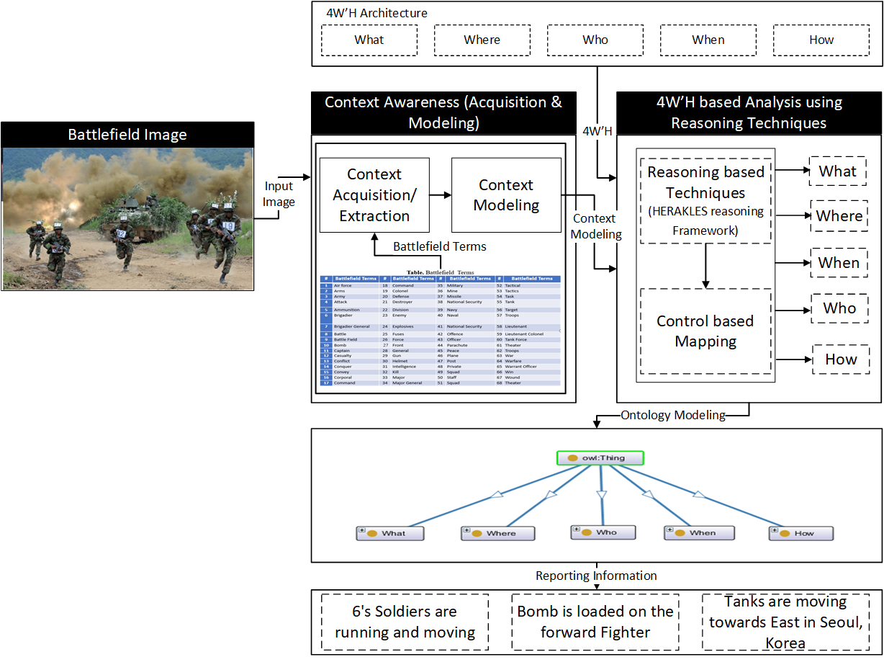
Fig. 1. Proposed architecture diagram of semantic ontology for battlefield situations reporting
The next step is context awareness model, which is responsible for the acquisition of battlefield context from battlefield images using domain knowledge (vocabulary). The main concepts and sub-concepts are highlighted based on the context source and acquisition process. After the extraction of concepts, it is required to use the context modelling process in order to map acquired concepts into 4W'H architecture. The 4W'H architecture consists of What (Type of Force and Weapons), Where (Geographic Location Coordinates and Reporting Place), When (Reporting and Access Time), Who (Soldiers and Tank), and How (Activities Monitoring of Enemies).
The important step of the proposed architecture is to map acquired concepts according to 4W'H architecture. For this, a reasoning-based HERAKLES framework [26] is utilised to model extracted concepts according to 4W'H architecture. The following Table 1 presents battlefield concepts mapped according to 4W'H architecture.
Table 1. Battlefield Terms mapped according to 4W'H Architecture.
What | Where | Who | When | How
Weapon | Tactical Operating Spot | Military Unit | Information  access Time | Activity Monitoring
Air Weapon | Military Tactics | Squad | Reporting  Time | Forward Activity
Ground Weapon | Air Tactics | Platoon | Timestamp | Prone Activity
Navel Weapon | Naval Tactics | Division | Quick  Time | Right Activity
Ammunition | War Place | Regiment | Date-Time  Group | Left Activity
Special Weapons | Ground War | Company | D-day | Up Activity
Type of Forces | Air War | Corps |  | Backwards Activity
Air Force | Sea War | Battalion |  | Down Activity
Naval Force | Boundaries | Brigade |  | National Security
Ground Force | Battalion Defence Area | Captain |  | Radio Channel
Battlefield Information | Company defence Area | Major |  | Fire Mission
Enemy Forces Information | Location coordinates | Major General |  | Delaying Action
Friendly Forces Information | Battle Area | Lieutenant Colonel |  | Combat Order
Weather | Phase Line | Brigadier General |  | Combat Plan
Win | Rear Area | Colonel
 | Sector of Fire | Warrant Officer
 | Security Area | Troops
 | Zone of Fire | Unit of Fire
 |  | Flank Guard

Semantic Ontology Modeling based on 4W'H Architecture
This section presents semantic ontology modelling based on 4W'H architecture to report battlefield situations semantically and effectively. Figure 2a presents semantic ontology developed in the Protégé tool for reporting battlefield situations semantically. The following fig. 2b is used to represent the XML schema of the developed semantic battlefield situations reporting ontology.
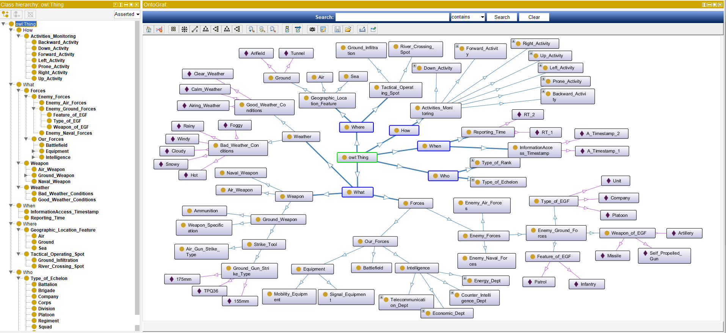
(a). Battlefield ontology modelling based on 4W'H architecture
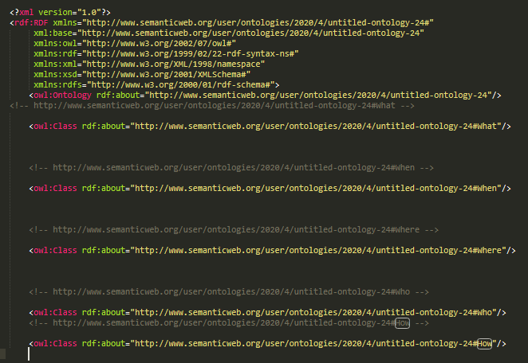
(b). XML schema
Fig. 2. Semantic battlefield ontology modelling based on 4W'H using Protégé tool.
Conclusions
This paper uses battlefield terms to present a semantic battlefield ontology based on 4W'H architecture. The proposed study collected battlefield terms from ATCIS databases and other relevant sources to form a domain knowledge. The main concepts are highlighted based on the context awareness model using battlefield domain knowledge. The open-source HERAKLES reasoning-based framework is used to map acquired terms into 4W'H architecture. The developed ontology is used to represent battlefield situations semantically and effectively. Furthermore, a well-known Protégé tool is utilised as an otology editor. The designed semantic ontology supports military officials in formulating effective strategies during battlefield tactics to counter the enemy's firepower. A use case example is defined to demonstrate the effectiveness of the designed semantic ontology to report battlefield situations semantically. Furthermore, this study reveals that semantic battlefield ontology based on 4W'H architecture can enhance the traditional ATCIS to report battlefield situations more intelligently and effectively.

Acknowledgements. This research was supported by Energy Cloud R&D Program through the National Research Foundation of Korea (NRF), funded by the Ministry of Science, ICT (2019M3F2A1073387), and this research was supported by Institute for Information & communications Technology Planning & Evaluation (IITP) grant funded by the Korea government (MSIT) (No.2019-0-01456, AutoMaTa: Autonomous Management framework based on artificial intelligent Technology for adaptive and disposable IoT). Any correspondence related to this paper should be addressed to Dohyeun Kim.

References
1. Gómez-Pérez, A., & Corcho, O. (2002). Ontology languages for the semantic web. IEEE Intelligent systems, 17(1), 54-60.
2. Paton, N. W., Stevens, R., Baker, P., Goble, C. A., Bechhofer, S., & Brass, A. (1999, July). Query processing in the TAMBIS bioinformatics source integration system. In Proceedings. Eleventh International Conference on Scientific and Statistical Database Management (pp. 138-147). IEEE.
3. Meštrović, A., & Calì, A. (2016, September). An ontology-based approach to information retrieval. In Semanitic Keyword-based Search on Structured Data Sources (pp. 150-156). Springer, Cham.
4. Ramli, F., Noah, S. A., & Kurniawan, T. B. (2016, August). Ontology-based information retrieval for historical documents. In 2016 Third International Conference on Information Retrieval and Knowledge Management (CAMP) (pp. 55-59). IEEE.
5. Munir, K., & Anjum, M. S. (2018). The use of ontologies for effective knowledge modelling and information retrieval. Applied Computing and Informatics, 14(2), 116-126.
6. Gruber, T. R. (1993). A translation approach to portable ontology specifications. Knowledge acquisition, 5(2), 199-220.
7. Xu, Z., Zhang, S., & Dong, Y. (2006, December). Mapping between relational database schema and OWL ontology for deep annotation. In 2006 IEEE/WIC/ACM International Conference on Web Intelligence (WI 2006 Main Conference Proceedings) (WI'06) (pp. 548-552). IEEE.
8. Trinkunas, J., & Vasilecas, O. (2007, June). Building ontologies from relational databases using reverse engineering methods. In Proceedings of the 2007 international conference on Computer systems and technologies (pp. 1-6).
9. Zhou, S., Ling, H., Han, M., & Zhang, H. (2010). Ontology Generator from Relational Database Based on Jena. Computer and Information Science, 3(2), 263-267.
10. Cullot, N., Ghawi, R., & Yétongnon, K. (2007, June). Db2owl: a tool for automatic database-to-ontology mapping. In SEBD (Vol. 7, pp. 491-494).
11. Van Der Vet, P. E., & Mars, N. J. (1998). Bottom-up construction of ontologies. IEEE Transactions on Knowledge and data Engineering, 10(4), 513-526.
12. Schreiber, G., Wielinga, B., & Jansweijer, W. (1995, August). The KACTUS view on the 'O'word. In IJCAI workshop on basic ontological issues in knowledge sharing (pp. 159-168).
13. López-Pellicer, F. J., Vilches-Blázquez, L. M., Nogueras-Iso, J., Corcho, O., Bernabé, M. A., & Rodríguez, A. F. (2007, October). Using a hybrid approach for the development of an ontology in the hydrographical domain. In Proceedings of 2nd Workshop of COST Action C21-Towntology Ontologies for urban development: conceptual models for practitioners.
14. Ra, M., Yoo, D., No, S., Shin, J., & Han, C. (2012, March). The mixed ontology building methodology using database information. In Proceedings of the International MultiConference of Engineers and Computer Scientists (Vol. 1).
15. Ra, M., Yoo, D., & No, S. (2013, June). Construction and applicability of military ontology for semantic data processing. In Proceedings of the 3rd International Conference on Web Intelligence, Mining and Semantics (pp. 1-7).
16. Ra, M., Yoo, D., No, S., Shin, J., & Han, C. (2013, February). Constructing a Military Ontology According to the Mixed Ontology Building Methodology. In Proceedings of the 5th International Conference on Computer Research and Development (ICCRD 2013), Vietnam.
17. Yoo, D., No, S., & Ra, M. (2014). A practical military ontology construction for the intelligent army tactical command information system. International Journal of Computers Communications & Control, 9(1), 93-100.
18. Matheus, C. J., Kokar, M. M., & Baclawski, K. (2003, July). A core ontology for situation awareness. In Proceedings of the Sixth International Conference on Information Fusion (Vol. 1, pp. 545-552).
19. Song, S., Ryu, K., & Kim, M. (2010, May). Ontology-based decision support for military information systems. In 2010 IEEE Long Island Systems, Applications and Technology Conference (pp. 1-5). IEEE.
20. Feng, Y. H., Teng, T. H., & Tan, A. H. (2009). Modelling situation awareness for Context-aware Decision Support. Expert Systems with Applications, 36(1), 455-463.
21. Song, J., Jun, D., & Wang, S. H. (2003). Analysing web ontology in Alloy: A military case study.
22. Chmielewski, M. (2009, October). Ontology applications for achieving situation awareness in military decision support systems. In International Conference on Computational Collective Intelligence (pp. 528-539). Springer, Berlin, Heidelberg.
23. Valente, A., Holmes, D., & Alvidrez, F. C. (2005, March). Using a military information ontology to build semantic architecture models for airspace systems. In 2005 IEEE Aerospace Conference (pp. 1-7). IEEE.
24. Bowyer, R. (2015). Dictionary of Military Terms: Over 6,000 words clearly defined. Bloomsbury Publishing.
25. Gortney, W. E. (2012). Dictionary of Military and Associated Terms.
26. Bock, J., Tserendorj, T., Xu, Y., Wissmann, J., & Grimm, S. (2009, October). A Reasoning Broker Framework for OWL. In OWLED.

